**IR security alarm**

**Introduction**

**IR based security alarm circuit** can detect any movement and trigger the alarm. This circuit is very useful in homes, banks, shops, restricted areas where an alert alarm is needed on any movement. This circuit is based on IR sensor where an IR beam is continuously falling on a photodiode, and whenever this Infrared beam breaks, by any kind of movement, alarm is triggered.

IR sensor consist an IR LED and photodiode, in which IR LED emits IR radiation and photodiode detects the radiation. Photodiode conducts current in reverse direction, whenever light falls on it, and voltage across it changes, this voltage change is sensed .

**IR based security alarm circuit** can detect any movement and trigger the alarm. This circuit is very useful in homes, banks, shops, restricted areas where an alert alarm is needed on any movement. This circuit is based on IR sensor where an IR beam is continuously falling on a photodiode, and whenever this Infrared beam breaks, by any kind of movement, alarm is triggered.

|  |  |
| --- | --- |
| Maximum Range | 80 cm |
| Minimum Range | 10 cm |
| Sampling Rate | 26 hz1 |
| Minimum Operating Voltage | 4.5 V |
| Maximum Operating Voltage | 5.5 V |
| Supply Current | 30mA2 |

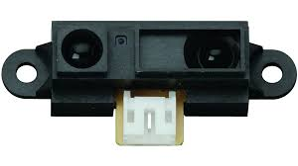

**Components:**

Arduino uno

IR sensor

Buzzer

Led

Breadboard

Transistor

Resistor

**Application**

This circuit is very useful in homes, banks, shops, restricted areas where an alert alarm is needed on any movement.

**Objective**

During this activity ,you will help students to achieve following objectives

1. Understanding the principle and operation of humidity sensor
2. Design algorithm and flowchart to detect humidity and temperature
3. Programming humidity sensor using Arduino uno
4. Interfacing humidity sensor withArduino uno

**Algorithm**

1. Initialise analog pin data pin port as A5
2. Initialise LEDas output port
3. Initialise sensor data input
4. Check data input signal at sensor input
5. If sensor value>700 ,the LED will glow and Buzzer rings.

**Flow chart**

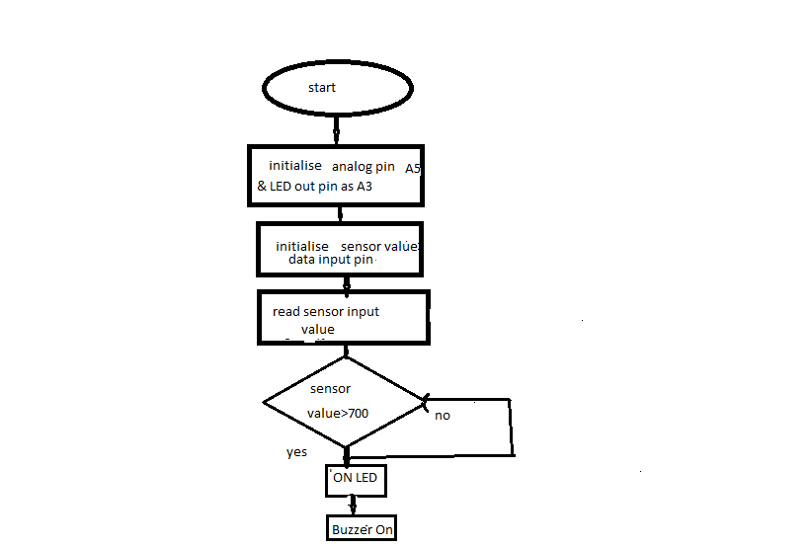

**Programming**

int analogInPin = A5;

int out =13;

int sensorValue = 0;

void setup() {

  Serial.begin(9600);

  pinMode(out, OUTPUT);

}

void loop() {

  sensorValue = analogRead(analogInPin);

  Serial.print("sensor = " );

  Serial.println(sensorValue);

  delay(200);

  if(sensorValue>700)

  {

    digitalWrite(out,1);

    delay(100);

  }

  else

  {

    digitalWrite(out,0);

  }

}

**Hardware**

**Instruction**

1. **Connect analog input A5 of Arduino to the pin 1 of sensor**
2. **connect pin3 of sensor to the vcc.**
3. **Digital input pin (pin13) of Arduino is to be connectd to the base of transistor**
4. **Make connection of transistor such that collector is connected to negative polarity of buzzer.**
5. **Pin 2 of sensor is connected to the emmiter of transistor.**
6. **Connect positive polarity of buzzer to vcc.**
7. 